

CSA0501-DATABASE MANAGEMENT SYSTEMS
LAB EXPERIMENTS DATE: 08/07/2026
EXPERIMENT 1 -- DDL Commands (CREATE, ALTER, DROP,TRUNCATE,RENAME)
AIM:
To create and manage the database structure for a milkdairy using Data
Definition Language (DDL) commands such as CREATE, ALTER, DROP, TRUNCATE,
and RENAME.
PROCEDURE:
1.Open MySQL and create the database for the milkdairy.
2.Use the CREATE command to create required tables such as amount,account number,phone number, bank name).Booking with suitable attributes and data types.
3.Use the ALTER command to add, modify, or remove columns from an existing table.
4.Use the RENAME command to change the name of an existing table.
5.Use the TRUNCATE command to remove all records from a table while keeping its
structure.
6.Use the DROP command to permanently delete an unwanted table from the database.
7.Use DESC table_name; or SHOW TABLES; after the operations to verify the changes.
8.Execute each command and observe the output to ensure that all DDL operations are
performed successfully.
PROGRAM:
1.CREATE DATABASE
CREATE DATABASE MILKDIARY;
Then select the database:
USE MILKDIARY;
OUTPUT:

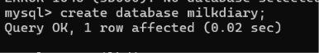

2.CREATE TABLE
CREATE TABLE MILKDAIRY (
name VARCHAR(20) ,liters INT(10),
amount INT(10),
account no INT (20),
phone no INT(12),
bank name varchar(10));

OUTPUT:
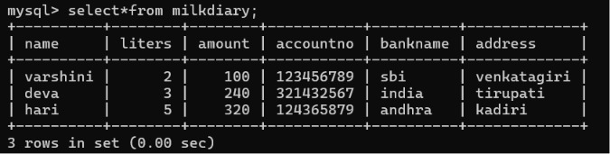
3.INSERT THE DATA
insert into milkdiary values
('varshini',2,100,123456789,6305006311,'sbi')
,('deva',3,240,321432567,6301171650,'india'),
('hari',5,320,124365879,12345667890,'andhra');
OUTPUT:

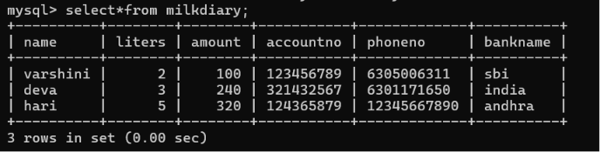
4)ALTER -ADD COLOUMN
Add a new column address:
update milkdiary set address='venkatagiri' where name='varshini';
update milkdiary set address='Tirupati’ where name='deva';
update milkdiary set address='Kadiri’ where name='hari';
output

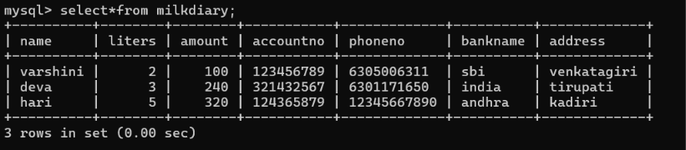

5.DROP COLUMN

Drop column phone number
alter table milkdiary drop column phone no
OUTPUT:



6)TRUNCATE
TRUNCATE TABLE MILK_DIARY;
Check;
SELECT*FROM MILK_DIARY;
The table be empty, but the table still exists..
OUTPUT:

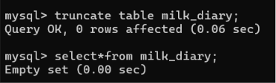

8.RENAME TABLE
Rename table milkdairy to milk_dairy

OUTPUT:
9.DROP TABLE 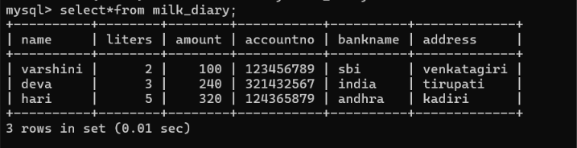RESULT:
Thus the DDL commands executed successfully.

